Batch:C3 Roll No.:16010123217

Experiment No. 8

Grade: AA / AB / BB / BC / CC / CD /DD

Signature of the Staff In-charge with date

TITLE: Implementation of Deadlock Avoidance Policy-Banker’s Algorithm
_____________________________________________________________________

AIM: Implementation of Deadlock Avoidance Policy-Banker’s Algorithm
______________________________________________________________________
Expected Outcome of Experiment:

CO3 Describe the problems related to process concurrency and the different synchronization mechanisms available to solve them.
_____________________________________________________________________
Books/ Journals/ Websites referred:

- Silberschatz A., Galvin P., Gagne G. “Operating Systems Principles”, Willey Eight edition.
- Achyut S. Godbole , Atul Kahate “Operating Systems” McGraw Hill Third
Edition.
- William Stallings, “Operating System Internal & Design Principles”, Pearson.
- Andrew S. Tanenbaum, “Modern Operating System”, Prentice Hall.
_____________________________________________________________________
Pre Lab/ Prior Concepts:
Banker’s Algorithm is a resource allocation and deadlock avoidance algorithm used in operating systems. It ensures that a system remains in a safe state by carefully allocating resources to processes while avoiding unsafe states that could lead to deadlocks.
The Banker’s Algorithm is a smart way for computer systems to manage how programs use resources, like memory or CPU time.
It helps prevent situations where programs get stuck and can not finish their tasks. This condition is known as deadlock.
By keeping track of what resources each program needs and what’s available, the banker algorithm makes sure that programs only get what they need in a safe order.
Components of the Banker’s Algorithm
The following Data structures are used to implement the Banker’s Algorithm:
Let ‘n’ be the number of processes in the system and ‘m’ be the number of resource types.
1. Available
It is a 1-D array of size ‘m’ indicating the number of available resources of each type.
Available[ j ] = k means there are ‘k’ instances of resource type Rj
2. Max
It is a 2-d array of size ‘n*m’ that defines the maximum demand of each process in a system.
Max[ i, j ] = k means process Pi may request at most ‘k’ instances of resource type Rj.
3. Allocation
It is a 2-d array of size ‘n*m’ that defines the number of resources of each type currently allocated to each process.
Allocation[ i, j ] = k means process Pi is currently allocated ‘k’ instances of resource type Rj
4. Need
It is a 2-d array of size ‘n*m’ that indicates the remaining resource need of each process.
Need [ i, j ] = k means process Pi currently needs ‘k’ instances of resource type Rj
Need [ i, j ] = Max [ i, j ] – Allocation [ i, j ]
Allocation specifies the resources currently allocated to process Pi and Need specifies the additional resources that process Pi may still request to complete its task.
Banker’s algorithm consists of a Safety algorithm and a Resource request algorithm.

Key Concepts in Banker’s Algorithm
Safe State: There exists at least one sequence of processes such that each process can obtain the needed resources, complete its execution, release its resources, and thus allow other processes to eventually complete without entering a deadlock.
Unsafe State: Even though the system can still allocate resources to some processes, there is no guarantee that all processes can finish without potentially causing a deadlock.

Implementation details:
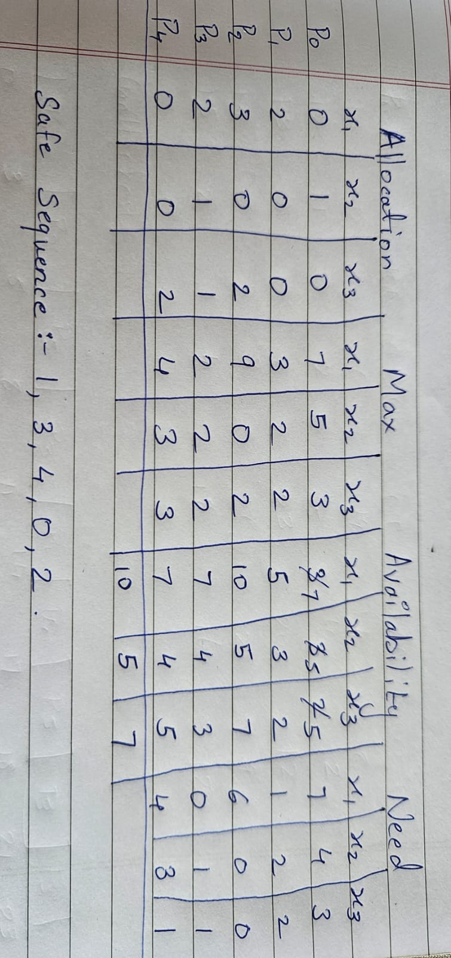

Code:-
#include<bits/stdc++.h>
using namespace std;

int main(){
int n, r;
cin>>n>>r;
vector<vector<int>> allocation(n, vector<int>(r, 0));
vector<vector<int>> Max(n, vector<int>(r, 0));
vector<vector<int>> Need(n, vector<int>(r, 0));
vector<vector<int>> Avail(n, vector<int>(r, 0));
vector<bool> finish(n, false);
cout<<"Allocation:\n";
for(auto &i : allocation) for(auto &j : i) cin>>j;
cout<<"Max\n";
for(auto &i : Max) for(auto &j : i) cin>>j;
cout<<"Availability First\n";
for(auto &i : Avail[0]) cin>>i;

for(int i = 0; i<n; i++){
for (int j = 0; j<r; j++){
Need[i][j] = Max[i][j] - allocation[i][j];
}
}
cout<<"Need:-\n";
for(auto i:Need){
for(auto j:i){
cout<<j<<" ";
}
cout<<endl;
}
vector<int> safeSequence;
int count = 0;
while(count < n){
bool found = false;
for(int p = 0; p < n; p++){
if(!finish[p]){
int j;
for(j = 0; j<r; j++)
if(Need[p][j] > Avail[0][j])
break;

if(j == r){

for(int k = 0; k<r; k++){
Avail[0][k] += allocation[p][k];
}

safeSequence.push_back(p);
finish[p] = true;
found = true;
count++;
}
}
}
if(!found){
return 0;
}
}

cout<<"Safe Sequence:-";
for(int i : safeSequence)
cout<<i<<" ";
cout<<endl;

return 0;
}

Output:-

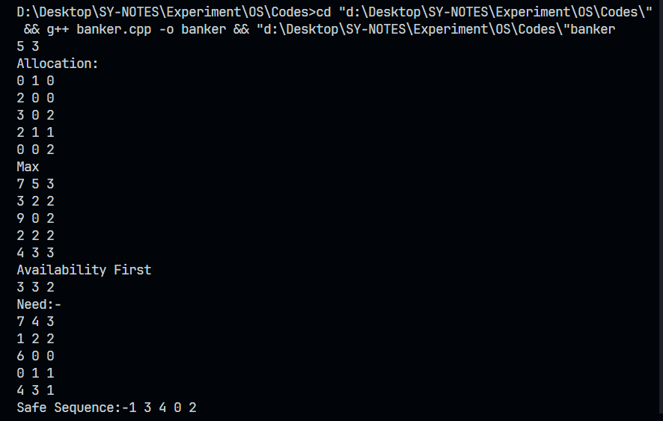

Conclusion :
In this experiment we have implement The Bankers Algorithms how to solve Deadlock for process and allocate resources accordingly thus to find best way to break it

Post Lab Descriptive Questions

- Assume that there are 5 processes, P0 through P4, and 4 types of resources. At T0 we have the following system state:
Max Instances of Resource Type A = 3
Max Instances of Resource Type B = 17
Max Instances of Resource Type C = 16
Max Instances of Resource Type D = 12
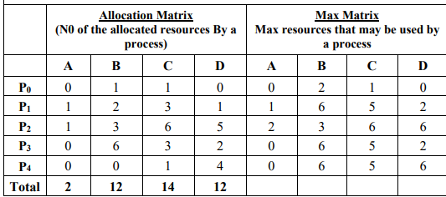
Find whether the system is in a safe state or not with the process sequence.
